Myers-Briggs, Leadership & Teams
Based on a lecture given by Prof. David Pendleton, RCGP (London), 4th July 2008
Put together by Dr. Ramesh Mehay, Programme Director (Bradford VTS)
For further reading: “We don’t need another hero” by David Pendleton

MYERS-BRIGGS TYPE INDICATOR
- MBTI is a theoretical model of personality TYPE – looking at your inbuilt ‘hardwired’PREFERENCES. It does not measure learning, stress, intelligence, emotions, illness, maturity or normality. The developers do NOT advocate its use in selection for employment because ALL types have ‘good’ in them.
- It was developed by Katherine Briggs and her daughter Isabel Briggs-Myers
- It is based on Carl Jung’s theories and practice
- It is conceptual in origin but the most widely used ‘personality’ measure in the world
- It is different from trait based measures (more later). It is a useful questionnaire to find out more about your ‘type’ and how that fits in with the team to which you belong
- It has fairly strong reliability and predictive validity
- There is no good and bad types – all can be good: depends on the tasks you are involved in
There are other questionnaires you may wish to explore further:
- NEO-PIR to determine how good you might be as a leader
- MVPI – to find out what drives you (Motives, Values, Preferences Inventory)
- HDS – how people react under pressure (Hogan Development Survey)
- http://www.performanceprograms.com/
- http://www.personalitytest.net/index.htm
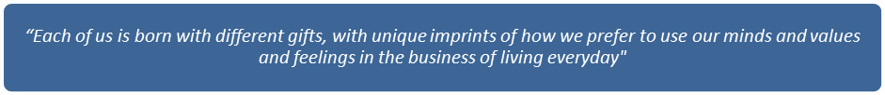
Briggs-Myers, ‘Gifts Differing’, Davies Black Publishing, 1980

How Can I Find Out My Type?
- You need to complete an MBTI questionnaire – usually found online
- Or you can get in touch with an experienced MBTI practitioner

Is There a ‘Quick and Dirty’ Way of Figuring Out My Type? (or that in others?)
Actually, there is. If you want to guestimate your type or that in others (you don’t want to do a questionnaire in every person before you interact with them!) ask for FOUR questions:
ENERGY SOURCE
- What would recharge your batteries? (or what fuels your energy?) If I were to invite you to a party, are you more likely to
- Hangout with people? (E for EXTROVERSION) or
- Withdraw from people? (I for INTROVERSION)
An alternative might be: Thinking about all the friends currently in your life
- Do you have lots and lots of friends (E) or
- Do you have a few friends but you know them VERY well (I)
INFORMATION PROCESSING
- If you try to learn something new, do you
- Immense yourself in detail and then try to get an overall picture? (SENSING) or
- Try to figure out the whole thing in a nutshell and then work on the detail? (INTUITION)
DECISION MAKING
- If you have a tough decision to make, are you more likely to:
- Analyse it and try to make a cold hearted decision that needs making? (THINKING) or
- Look at yours or others values, feelings? (FEELING)
ORGANISING LIFE
- Think of the unstructured time in your life (your free time, your own time, like the weekends)
- Do you have to structure it (JUDGING) or
- Are you happy to leave it unstructured and do what the day provides? (go with the flow) PERCIEVING
An alternative might be: When you plan your holidays, do you
- Plan them well in advance and know when your holidays are and roughly where you’re planning on going? (JUDGING) or
- Tend to leave it all last minute? (PERCIEIVING)
Now put the four letters together eg E N F P

What is Personality ‘Type’?
- It’s about normal differences
- Is helpful in understanding yourself and other people
- Is about you inside – how you are ‘hardwired’
- Also considers what you do and how you behave
- ….and remember we are all INDIVIDUALS!

Approaches to Personality – differences between trait and type
Trait
- Frequently empirically derived
- Behaviour based
- Reliable and valid
- Many dimensions, but narrow in focus
- Examples include: OPQ, NEO-PIR
Type
- Theoretically based
- Preference based
- Look inside you – deep ‘hardwiring’ of psyche
- Examples include MBTI, JTI

LEADERSHIP

What is Leadership?
It’s about collective completeness, not individual completeness. In other words, you need to get the whole team working effectively together.

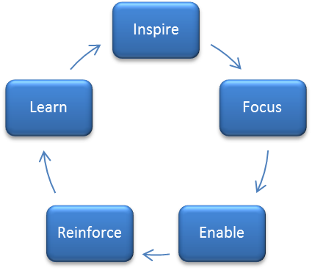
The Tasks of Leadership
There are 5 tasks you need to achieve for effective leadership. As an effective leader, you need to:
Let’s talk about each in turn.

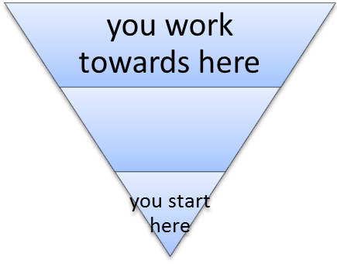
Inspire
- Inspiration is all about the world of imagination and getting those around you to ‘buy in’ and want more. It’s about ‘hooking them’ and not about pushing them!
- It’s about breathing life into a team
- It’s conceptual (all about concepts) and is broad.
- If you could represent it as a diagram, it would look something like this:
Inspiration has an intellectual component and an emotional component.
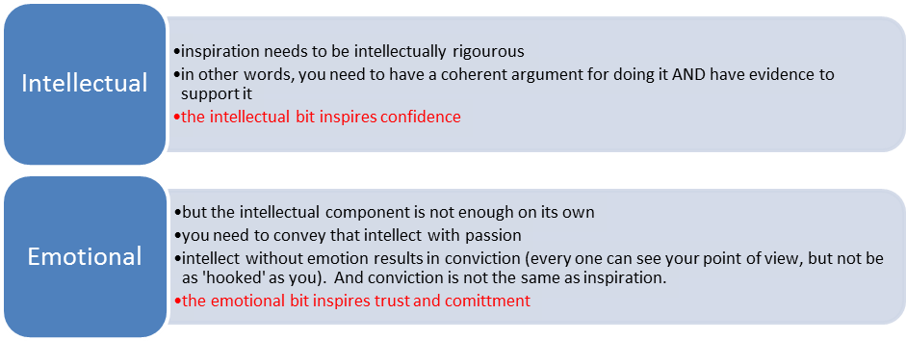
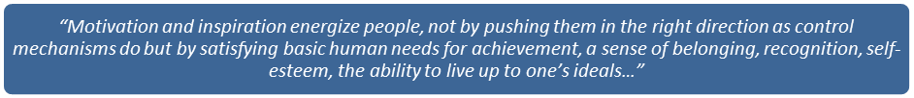
John Kotter, 2001, “What Leaders Really Do”, HBR

Focus
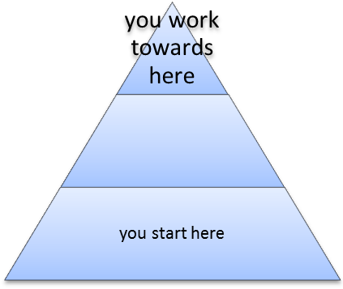
- Focus is what transforms enthusiasm (inspiration) into productive effort
- It makes things happen; people who have great focus make things happen
- Focus is sequential – you have to work out the individual steps you need to take in sequence to make things happen. It’s about asking the questions: “What do we do 1st?”… and then what?.... and then what? etc
- It ranges from strategy through plans to objectives and priorities
- If you could represent it as a diagram, it would look something like this:
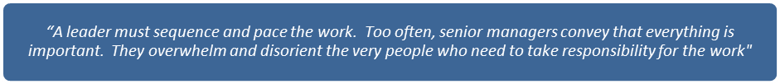
Ronald Heifetz and Donald Lawrie, The Work of Leadership, (1997, 2001, HBR)
In other words, the old adage “when everything is important, nothing is important”. So figure out what is important.

Enable
- Enabled people are clear about what they are trying to achieve; they have the mandate, resources and skills to act
- This is what you need to achieve within your team: ‘make it possible’
- To do this you need to give clear instructions, give them authority, give them resources and STOP INTERFERING – let them get on with it.
- What you’re really doing is giving people control over something. Did you know that if you give people control and empower them, they are less likely to have work related stress and yet they work harder. Yes! They work harder and report LESS stress.
- Leaders don’t need to be empowered: they are self empowering! And they empower others.
- As a leader, one needs to create a framework (or sense of direction) in which people (your team) can make their own decisions to get there.
- Once enabled, you must never stop enabling or it all falls apart.
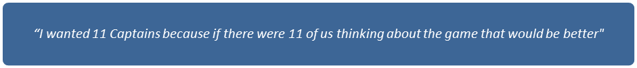
Michael Vaughan, England’s most successful cricket captain, after winning the Ashes against Australia.

Reinforce
- We need to create a ‘moral’ world in which performance is reviewed.
- In this world:
- Good performance is signposted and rewarded. By signposting, we mean specifying exactly what about that performance was good (so that the person continues to do it)
- People who are struggling are helped (not told off)
- Persistent poor performers are removed
- Leaders doesn’t necessarily do all the reinforcing. But what (s)he must do is CREATE A SYSTEM for doing this within that organisation. In other words, everyone does the reinforcing (not just those at the top).
- This is one of the ways we convince our people that we can be trusted.

Learn
- Learning turns
- failure into success
- competence into excellence
- We need to nurture an organisation which encourages people to want to learn and to learn for themselves
- We all learn from our mistakes (not all mistakes need disciplinary action; instead view a mistake as a learning point – hopefully they won’t take that approach again). When the company IBM was at the top of its niche, their manager (Watson) employed a new graduate who lost them 10million dollars. The graduate was called into the office and Watson gave him his next task. Puzzled (and expecting to be fired) the graduate asked why he had not been fired, to which Watson replied: ‘why would I want to fire someone who’ve I’ve just given a 10 million dollar lesson to?’
- Like reinforcement, leaders need to create learning systems, not necessarily doing all the learning itself.
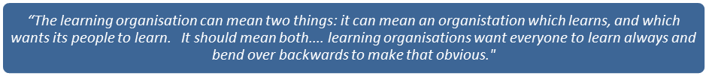
Charles Handy, The Age of Unreason, 1991

Tying this all Together
If you find that as a leader you have weaknesses in one or more of the areas (providing it’s not all five!), try and look at what you’re good at and what you’re not good at and which parts of your personality helps that and hinders that. Mapping out a table like the one below might be helpful.
 | Leadership skills you are GOOD at | Leadership skills you are NOT GOOD at
Bits of your personality that help with this | You need to work with and on these in order to develop to world class | You need to work on these to become competent
Bits of your personality that don’t help with this | You need to work on these to maintain competence | You need to work around the issue (what you’re not good at) and find solutions.  -You need to find things to mitigate the effects of your personality.  -The individual is still accountable.  -Different solutions may need exploration (eg you may wish to delegate to someone who is good).

What is the Key to Successful Organisations?
Successful organisations work on and fine tune 3 domains:
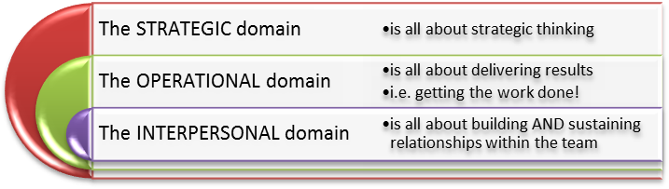

Tying this all Together
The 5 skills for leadership and these 3 domains are interlinked:

needs planning and organisation  need to create alignment | 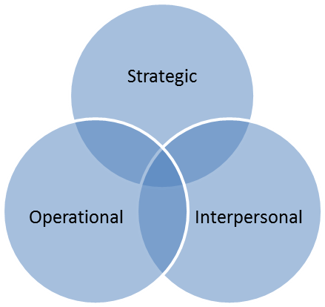 | needs leadership  needs teamwork

The 5 Core Tasks of Leadership

The greater danger for most of us is not that our aim is too high and we miss it, but that our aim is too low and we hit it.
Michaelangelo

MYERS-BRIGGS TYPE AND TEAMS

Diversity is the Key
For effective teams, you need people who are different from you. In other words, the more diverse your team, the richness in skills there will be. So, if you’re employing a new member of staff, try not to employ someone who thinks and acts like you. Get someone different. Why have two of you? Wouldn’t it be better to get perspectives which you (for instance) might not have had insight into?

Myers-Briggs Types and How Well They Do in Teams
If you don’t understand this bit, you need to go back and read up the basics on Myers-Briggs Type Inventory. It’s a good questionnaire to learn more about yourself.

Myers-Briggs Type as Leaders
Okay, we know you need 5 things for good leadership. But which of the Myers-Briggs type do particularly well at each of the tasks?
INSPIRE
- E for Extroversion - because they inspire with dynamism and enthusiasm
- N for Intuition – because they inspire with passion
FOCUS
- S for Sensing – because they are practical, like facts and are stepwise/sequential in the activities
- T for Thinking – because they use their head, are logical, objective and can critique
- J for Judging – because they plan, categorise, are decisive and organised
ENABLE
REINFORCE
LEARN
ISTJ  Authoritarian, direct, hierarchical, respected | ISFJ  Caring, rule orientated, quiet | INFJ  Personal, predictable, queit | INTJ  Planning orientated, visionary, single minded
ISTP  Egalitarian, pragmatic, expedient | ISFP  Understanding, human, easy going | INFP  Caring, democratic, participative, unassuming | INTP  Principle oriented, visionary, autonomous
ESTP  Pragmatic, expedient and with flair | ESFP  Easy going yet pragmatic, expedient | ENFP  Democratic, participative, energetic | ENTP  Communicative, visionary, autonomous
ESTJ  Results oriented, co-operative, authoritarian, decisive | ESFJ  Softly authoritarian, decisive, respectful of heirarchy | ENFJ  Democratic, participative, people oriented | ENTJ  Action orientated and visionary, takes charge

Change and SJs
- Need: data and proof that it will really work – that it will improve things
- Want: to know what is expected of them, how their job will be affected, to see all the steps between now and the future vision
- Want: to know who will be responsible for each step, things to be decided and clear
- Have: difficulty with uncertainty
- Feel: overwhelmed by too many possible directions
- Focus: on practical requirements and results

Change and SPs
- If: change is coming want to plunge in, see how it goes and make adjustments along the way
- Need: to take action, little tolerance for analysis
- Enjoy: risks and respond to crisis and changes of the moment
- Are: energised by the unexpected, the different and irritated by long term change planning and timelines
- Like: ‘how to’ problems
- Dislike: ‘why’ questions
- Focus: on immediate effects

Change and NTs
- Want: to be involved in planning change and designing logistics
- Create: plans based on larger perspective – seeing all ramifications
- See: almost all change as improvement
- Are: bored by doing things the same old way
- If: not involved in planning and if it seems illogical or unfair can detach, disinvest and become the cynical critic
- Focus: on the logical systems involved

Change and NFs
- Experience: change first as loss because they have attachments to people, places and objects
- Have: great loyalty to people and to the organisation the way it has been
- Identify: with people caught up in the change, especially those negatively affected
- Want: those in charge to listen to their opinions
- When: they see the new possibilities and perceive that people’s needs will be met, generate great enthusiasm, energy and optimism to help others
- Focus: on the impact on people

